# MANP098 – BUSINESS ANALYTICS CASE STUDY ASSIGNMENT

**Submission: Friday 13th September at 11am.**

**This is an individual project task, which must be undertaken on your own, and not in co-operation with any other person.**

## Introduction

Stirling Council has recently implemented an ERP solution, Oracle Fusion Cloud, a single integrated solution that will be externally hosted and supported. A Software as a Service (SaaS) contract has been put in place where the supplier, Oracle, is responsible for the provision of this service including quarterly product upgrades, support and maintenance services and disaster recovery capability.

Oracle Fusion Cloud has replaced the Council’s core Finance, Procurement, HR and Payroll systems. The Vision for the Council is to consolidate these core systems and improve business processes, making them more dynamic as well as improving the Council’s data analytics and insight capabilities.

Having replaced out-dated systems and by improving existing processes, introduced workflow and improved integration this will allow consistent and real-time reporting.

There is an opportunity to review Stirling Council’s data strategy in the context of this new ERP system and look at the potential to bring together organisational data with a view to improving service delivery as well as how the Council uses data in decision-making.

## Enterprise Resource Planning Across a Large Organisation

Stirling Council would like to make the most of our ERP system as soon as possible and there is an opportunity to help our internal teams shape the data analytics model that we put in place that will support and influence decision-making. Within the context of shaping Stirling Council’s data strategy, the project could also help to advise on data management standards across the Council with a particular focus on data integrity and data security.

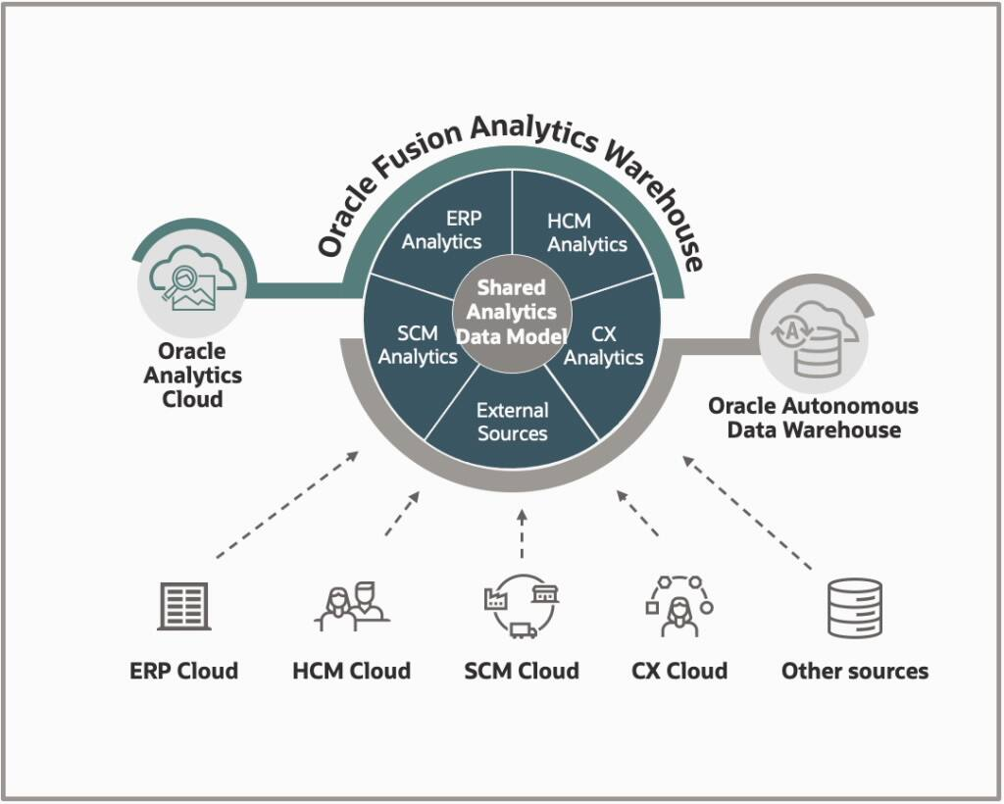

The work will involve working with data extracted directly from Oracle Fusion and other supporting systems and analysing using Power BI. The council want to extract various types of information from the ERP.

Tasks that need to be addressed include:

* Defining a suite of key performance indicators from each silo of the organisation (Finance, Procurement, HR and Payroll systems) that can be extracted on a regular basis and monitored over time.
* Develop a system Balanced Scorecard around the data contained within the ERP system and based on the new suite of performance indicators
* Building reports across key service areas that can be run regularly and will show trends over time.
* Supplier analysis – analysing our current supplier list and categorising appropriately.
* Investigate options of data quality reporting to ensure the ongoing integrity of our data
* Review current data management standards across systems to establish standardisation and integrity.

# Your Tasks

You are to prepare **a 10,000 – 12,000 word report** as a response to 12 weeks of case study work on a project in analysing ERP data to support decision making in Stirling Council. You are to submit with that report, a management visualisation output, in the form of a tool that you have developed, in order that your findings can be explored.

1. As you prepare your response, keep in mind the ethical questions that arise, as well as questions of sustainability, disruption, and risk management.
2. Undertake an appropriate level of analysis via stages 1-5 of CRISP-DM, or similar, to explore the regarding the context of the problem, and the solution you intend to produce.
3. Include a chapter describing any methodology you adopt, clearly explaining and justifying the methods used in the production of your associated tool.
4. Develop visual representations of your key findings using suitable tools and techniques covered in your MSc programme. Use your creativity to present the data findings in a meaningful way.
5. Prepare a management report to present your findings based on your analyses above. Your report must include suitable recommendations connected explicitly to evidence generated from your analysis and their implications for how your finding can be used to improve Health and Social Care outcomes.

YLE AND FORMAT NOTES

# Data and Support Materials

1. This case's dataset and associated supporting materials have been dataset **provided to you** as part of this case study pack. The datafiles and associated materials can be found [here](https://stir-my.sharepoint.com/:f:/r/personal/tbk3_stir_ac_uk/Documents/CaseStudy2024?csf=1&web=1&e=4KSiA9).
2. In this pack you will find the following file:
   1. Various datasets that may be useful to you in approaching the case study
   2. Various files and support documents provided by the Case Study authors to help you in preparing your response
3. You are allowed to augment the data files if you have access to useful secondary data sets to support your analysis work. Please note, you should not work with primary data.

# Marking criteria

Your report will be marked based on the University's Postgraduate Common Marking Scheme (available here: [https://www.stir.ac.uk/about/professional-services/student-academic-andcorporate-services/academic-registry/policy-and-procedure/assessment-policy-andprocedure/)](https://www.stir.ac.uk/about/professional-services/student-academic-and-corporate-services/academic-registry/policy-and-procedure/assessment-policy-and-procedure/) against the following criteria:

1. Problem Definition (background, rationale, aims/objectives/questions, hypotheses)
2. Problem Exploration and Analysis (including identification of organisational data and relevant literature)
3. Methodology (detail on the research design, its justification and execution)
4. Findings Analysis and Discussion (relevance of findings and approach to analysis; link between research results and the project objectives, business implications and relevant literature)
5. Conclusions and Recommendations (relevance to project objectives, organisational context and personal learning)
6. Standard of Presentation (structure, presentation, logic and referencing)

# University's Academic Policy and Procedure and Proofreading Policy

1. This case study is an individual task. You must conduct the analysis and write the report yourself.
2. You MUST NOT undertake any primary data collection.
3. You MUST avoid the unauthorised use of large language model (LLM), including any Artificial Intelligence (AI) model such as ChatGPT or paraphrasing application, such as QuilBot AI, to conduct analysis, write and/or present your work, whether in part or the whole piece of your assessment.
4. Note the University proofreading policy is available here: [https://www.stir.ac.uk/media/stirling/services/academicregistry/documents/policy-proofreading-oct-2023.docx.](https://www.stir.ac.uk/media/stirling/services/academic-registry/documents/policy-proofreading-oct-2023.docx)
5. The University's Academic Integrity Policy and Procedure can be viewed here for more detail: [https://www.stir.ac.uk/media/stirling/services/academicregistry/documents/policy-procedure-academic-integrity-v5-2023.docx](https://www.stir.ac.uk/media/stirling/services/academic-registry/documents/policy-procedure-academic-integrity-v5-2023.docx)

# Submission

1. 10,000 to 12,000 words report.
2. Submitted via Canvas before the deadline indicated.
3. You must **submit your report in MS Word**, include any associated files for your data analysis, e.g. Power BI, Orange DM, MS Excel, R Studio scripts etc.
4. The associated files and/or scripts will be used to validate the report you submit.
5. Ensure that you save your associated documents, as you may be required to exhibit them along with your analysis.

SUBMISSION AND ASSESSMENT

This final report is to be submitted through Canvas by **Friday 13th September at 11am.**

**You are reminded that evidence of plagiarism may result in disciplinary action.**

## MARKING GRID

